Playwright Installation
- Please raise Eforms for following Software’s in open source category
Prerequisites software's for playwright installation :
a)Node.js
b)Node Package Manager (NPM)
c)code editor - preferable Visual Studio Code or IntelliJ.

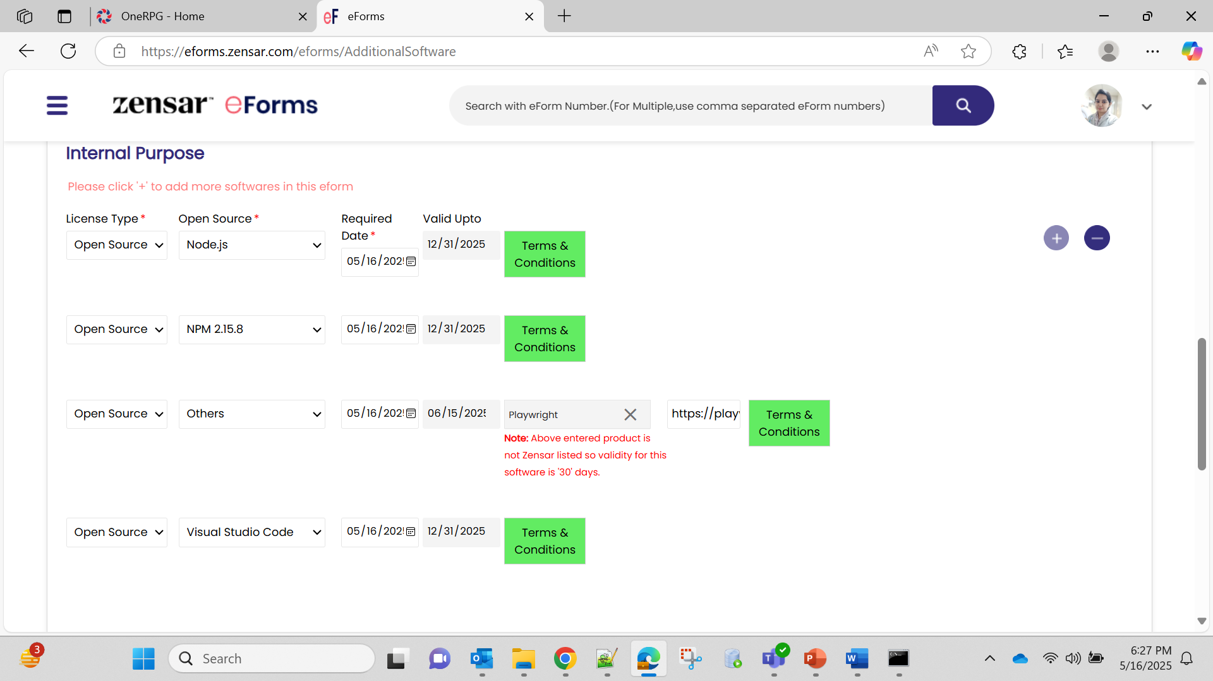
- Download node.js for windows from below URL: (kindly download windows installer)
https://nodejs.org/en/download

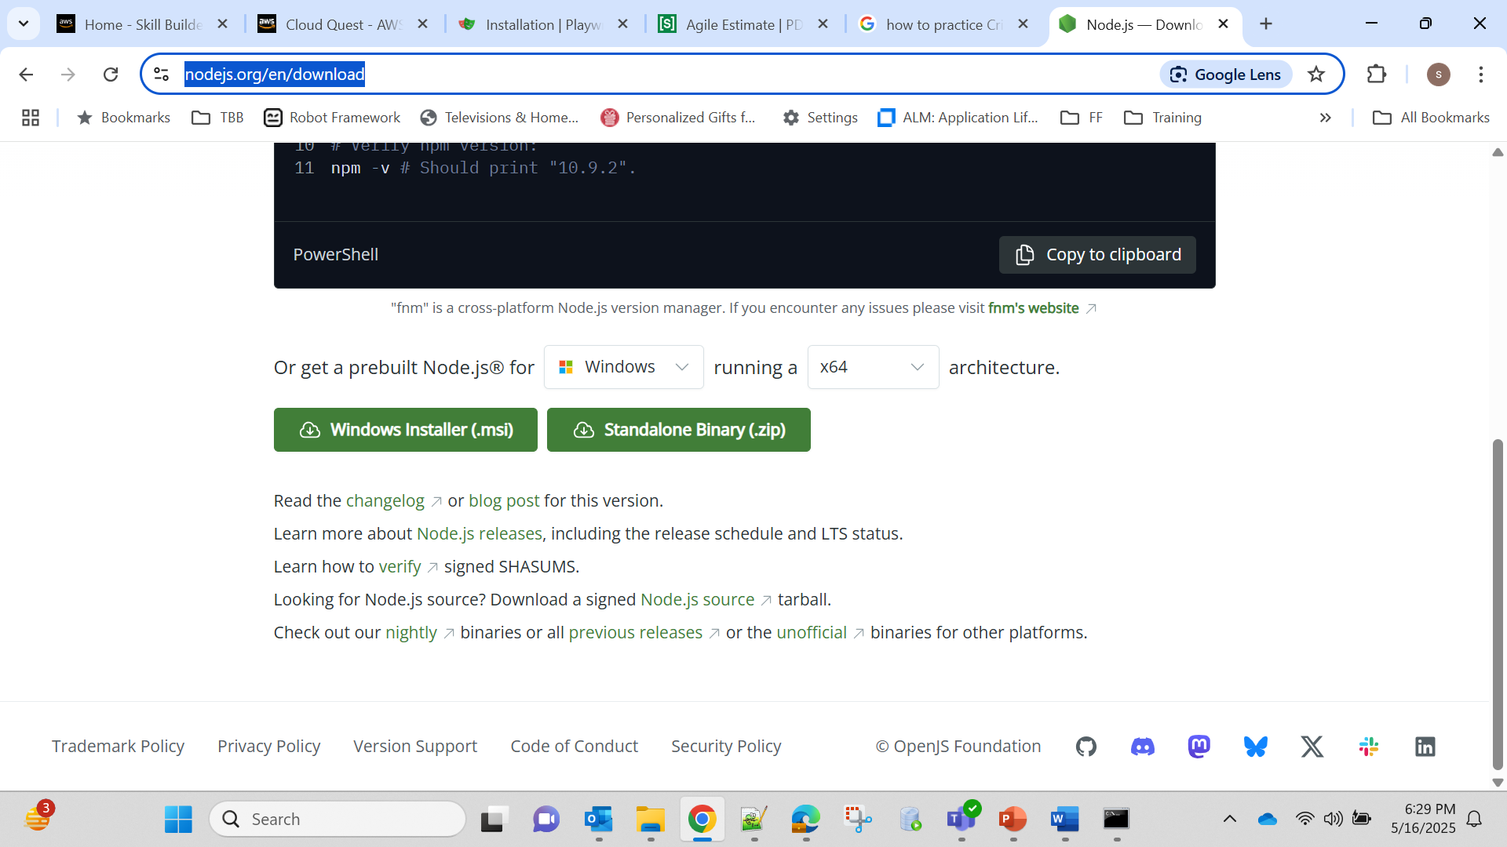

- Playwright installation :
Installing Playwright​
Get started by installing Playwright using npm, yarn or pnpm.
- npm
- yarn
- pnpm
Command -> npm init playwright@latest
Run the install command and select the following to get started:
- Choose between TypeScript or JavaScript (default is TypeScript)
- Name of your Tests folder (default is tests or e2e if you already have a tests folder in your project)
- Add a GitHub Actions workflow to easily run tests on CI
- Install Playwright browsers (default is true)
- Running the Example Test
Command -> npx playwright test
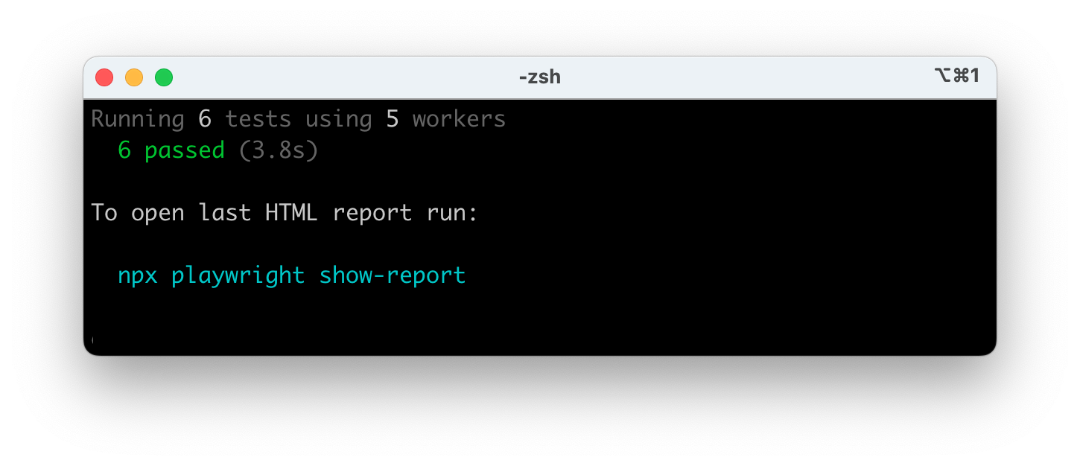
- Run Test in UI
Command -> npx playwright test –ui

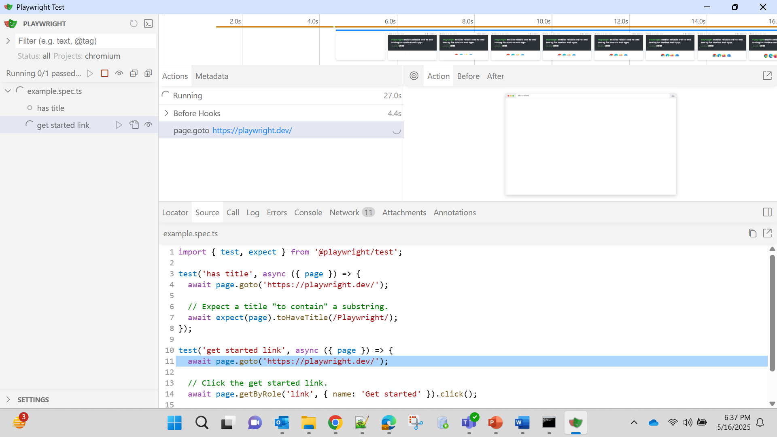

- If getting Error related to User like shown in below screenshot, please contact network administrator immediately.
C:\Users\VR76116\Automation\Playwright> npx playwright install
Downloading Chromium 136.0.7103.25 (playwright build v1169) from https://cdn.playwright.dev/dbazure/download/playwright/builds/chromium/1169/chromium-win64.zip
Error: unable to get local issuer certificate
at TLSSocket.onConnectSecure (node:_tls_wrap:1679:34)
at TLSSocket.emit (node:events:518:28)
at TLSSocket._finishInit (node:_tls_wrap:1078:8)
at ssl.onhandshakedone (node:_tls_wrap:864:12) {
code: 'UNABLE_TO_GET_ISSUER_CERT_LOCALLY'

